Operational amplifiers are one of the most useful circuit blocks for analog electronic circuit design. They are easy to use and can provide some near perfect analogue circuits.

The operational amplifier has two inputs. One is called the inverting input and is marked with a "-" sign on circuit schematic diagrams. The other is the non-inverting input and this is marked with a "+" sign.

The op amp is basically a differential amplifier because the output is proportional to the difference in voltage between the two inputs

The two inputs gain their names from the way in which they amplify the signals:

* ***Non-inverting input:***   The operational amplifier non-inverting input is marked by a "+" sign on the circuit diagram. It is found that a positive voltage applied to the non-inverting input will produce a positive swing at the output. If a changing waveform, such as a sine wave is applied to the non-inverting input, then it will appear in the same sense at the output. It has not been inverted.

The operational amplifier is called so because it has its origins in analog computers, and was mainly used to perform mathematical operations. Depending on its feedback circuit and biasing, an op-amp can be made to add, subtract, multiply, divide, negate, and interestingly even perform calculus operations like differentiation and integration

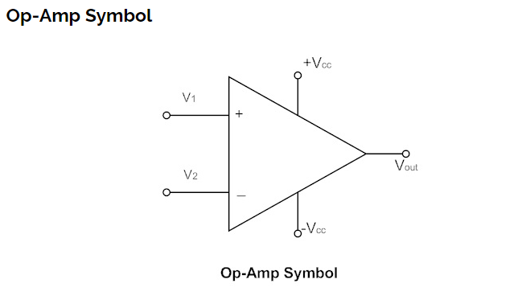

If an input signal is applied to either of the input terminals to the other input terminal connected to ground, the operation is called “single-ended”.

In single-ended operation a single input applied, drives both the transistors due to the common-emitter connection. The output obtained is thus driven by both the collectors.

2. If two input signals are applied to the two input terminals the operation is referred to as “double-ended”.

In double-ended operation the difference of the inputs applied to the two input terminals drives the transistors and the output obtained is driven by both the collectors.

If the same input is applied to both inputs, the operation is called “common mode”. In common-mode operation the common input signal at both the input terminals results in opposite signals at each collector. These signals get cancelled, resulting in an output signal zero. Practically, the opposite signals do not completely cancel each other and a small signal is resulted in the output.

**Differential Amplifier using Transistors**

All op-amps consist of a differential amplifier at their input stage. If two different voltage signals are applied to the two input terminals of the op-amp, the resulting output signal is proportional to the “difference” between the two signals. Thus the differential amplifiers amplify the difference between two voltages measured with respect to a common reference. The differential amplifier stage of an op-amp is as shown below.

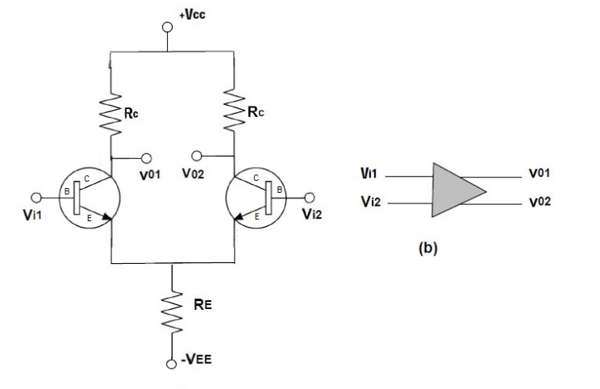

The two transistors Q1 and Q2 have identical characteristics. The two input signals Vi1 and Vi2 are applied to the base terminals of Q1 and Q2 respectively. Note that the differential amplifier has two output terminals VO1 and VO2.

Ideally, the output voltage is zero when both the inputs are equal. When Vi1 is greater than Vi2, the output terminal VO1 will be positive and VO2 will be negative. When Vi2 is greater than Vi1, the output terminal VO2 will be positive with respect to VO1.

The output VO is given by,

VO = AD (Vi1 – Vi2)

Where AD is the differential gain.

The ability of a differential amplifier to reject a common mode signal is expressed in terms of its common mode rejection ratio (CMRR). Higher value of CMRR represents its better ability to reject common mode signals. Thus any undesired signal such as noise or an interference pickup would appear as common to both the input terminals and the effect of this signal on the output would be zero. CMRR is the ratio of differential gain to the common mode gain of the differential amplifier, i.e. CMRR = AD /AC

Where, AD = VO / (Vi1 – Vi2)

and AC = VO(CM) / Vi(CM)

### 

The equivalent circuit of an ideal op-amp is shown above. The input voltage VDIFF is the difference voltage (V1-V2). Zin is the input impedance and Zout is the output impedance. The gain parameter A is called the open loop gain. If an op-amp does not have any feedback from the output to either of the inputs, it is said to be operating in open-loop configuration.

An ideal op-amp exhibits infinite open loop gain, infinite input impedance, zero output impedance, infinite voltage swing, infinite bandwidth, infinite slew rate and zero input offset voltage.

[Back to List](https://www.electronicshub.org/operational-amplifier-basics/#BackToList)

### Operational Amplifier Characteristics

#### Input Impedance (Zin)

An ideal op-amp has infinite input impedance to prevent any flow of current from the supply into the op-amp circuit. But when the op-amp is used in linear applications, some form of negative feedback is provided externally. Due to this negative feedback, the input impedance becomes

Zin = (1 + AOL β) Zi

Where, Zin is the input impedance without feedback

AOL is the open-loop gain

β is the feedback factor (1 for voltage follower)

The impedance of the signal sources connected to the input of an op-amp must be very much smaller than the amplifier input impedance to avoid signal loss.

[Back to List](https://www.electronicshub.org/operational-amplifier-basics/#BackToList)

#### Output Impedance (Zout)

An ideal op-amp has zero output impedance. This means that the output voltage is independent of output current. Thus an ideal op-amp can act as a perfect internal voltage source with zero internal resistance, so that maximum current can be driven to the load.

Practically, the output impedance of the op-amp is affected by the negative feedback and is given by,

Zout = Zo / (1 + AOL β)

​

Where, Zo is the output impedance of op-amp without feedback

AOL is the open-loop gain

β is the feedback factor

Load impedances connected at the output of the op-amp must be much larger than the circuit output impedance, to avoid any significant loss of output as a voltage drop across Zout.

[Back to List](https://www.electronicshub.org/operational-amplifier-basics/#BackToList)

#### Open-Loop Gain (AVO)

Open-loop gain of an op-amp is defined as the gain of the op-amp when there is no feedback from the output to either of its inputs. For an ideal op-amp, the gain will be infinite theoretically, but practical value range from 20,000 to 200,000.

[Back to List](https://www.electronicshub.org/operational-amplifier-basics/#BackToList)

#### Bandwidth (BW)

An ideal op-amp can amplify any frequency signal from DC to highest AC frequencies, thus it has an infinite frequency response. Therefore, the bandwidth of an ideal op-amp should be infinite. In practical circuits, the bandwidth of the op-amp is limited by the gain-bandwidth product (GB).

[Back to List](https://www.electronicshub.org/operational-amplifier-basics/#BackToList)

#### CMRR (Common Mode Rejection Ratio)

CMRR is defined as the ability of an op-amp to reject the common mode input signal. CMRR is an important measure of an op-amp. An ideal op-amp will have infinite CMRR. In practical circuits, CMRR is given by

CMRR = 20 log10 (AD/|AC|) dB

Where, AD is the differential gain and AC is the common mode gain of the op-amp.

[Back to List](https://www.electronicshub.org/operational-amplifier-basics/#BackToList)

#### Offset Voltage (VIO)

The input offset voltage defines the differential DC voltage required between the input terminals to make the output zero volts with respect to ground. An Ideal op-amp will have zero offset voltage, whereas practical op-amps show some small offset.

[Back to List](https://www.electronicshub.org/operational-amplifier-basics/#BackToList)

#### Slew Rate

Slew rate is defined as the maximum change of output voltage per unit time and is expressed as volts per second. An ideal op-amp will have an infinite slew rate. In practical op-amps, the slew rate is inherently limited by the small internal drive currents of the op-amp and also by the internal capacitances designed to compensate for high frequency oscillations.

[Back to List](https://www.electronicshub.org/operational-amplifier-basics/#BackToList)

